**DAILY ONLINE ACTIVITIES SUMMARY**

|  |  |  |  |  |  |  |  |  |
| --- | --- | --- | --- | --- | --- | --- | --- | --- |
| **Date:** | **08/06/2020** | | | | | **Name:** | **Archana J C** | |
| **Sem & Sec** | **4th**  **‘A’** | | | | | **USN:** | **4AL18CS011** | |
| **Online Test Summary** | | | | | | | | |
| **Subject** | | **Aadalitha kannada** | | | | | | |
| **Max. Marks** | | **25** | | **Score** | | | **23** | |
| **Certification Course Summary** | | | | | | | | |
| **Course** | **Python and Django full stack web developer bootcamp** | | | | | | | |
| **Certificate Provider** | | | **Udemy** | | **Duration** | | | **2hours** |
| **Coding Challenges** | | | | | | | | |
| 1. **Given two positive integer start and end. The task is to write a Python program to print all Prime numbers in an Interval.** | | | | | | | | |
| **Status: Completed** | | | | | | | | |
| **Uploaded the report in Github** | | | | | **Yes** | | | |
| **If yes Repository name** | | | | | **https://github.com/alvas-education-foundation/archana_j_c** | | | |
| **Uploaded the report in slack** | | | | | **Yes** | | | |

Online Test Details: (Attach the snapshot and briefly write the report for the same)

It was from all the chapters and the test was for 25 minutes having 25 questions all multiple choice questions. The question were simple and optimal and the score that I got was 23/25.

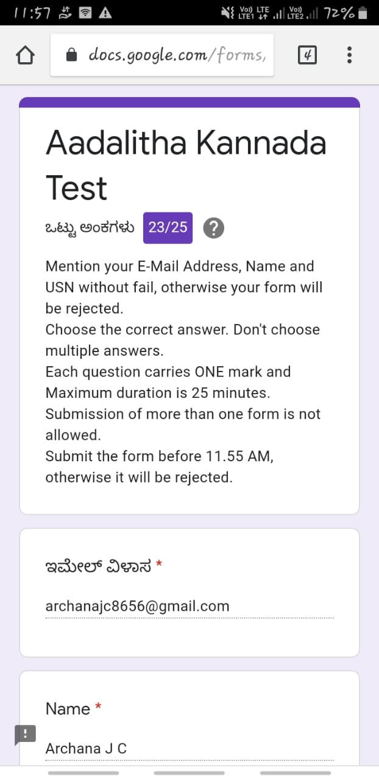

Certification Course Details: (Attach the snapshot and briefly write the report for the same)

COURSE NAME : **Python and Django full stack web developer bootcamp**

CERTIFICATION PROVIDERS : Udemy

The course is all about the web development. I was learnt about html and css, and how to code using html and I’m know in javascript advance.

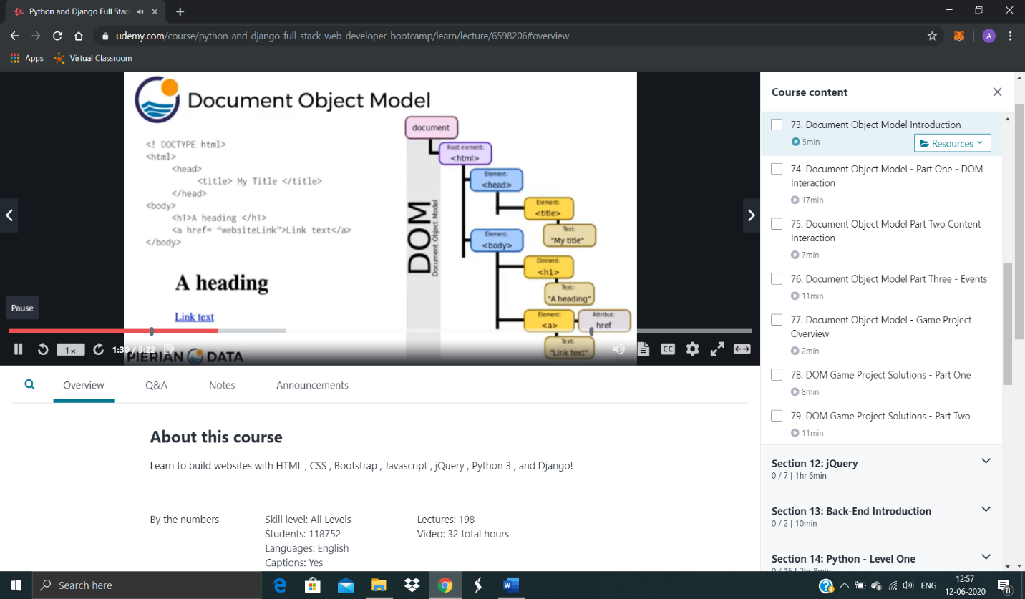

Coding Challenges Details: (Attach the snapshot and briefly write the report for the same)

Today I’m done with some python programs. The solution are already uploaded in github repository

**Program1 :** **Given two positive integer start and end. The task is to write a Python program to print all Prime numbers in an Interval.**

